MarineGEO Seagrass Habitat Monitoring Protocol

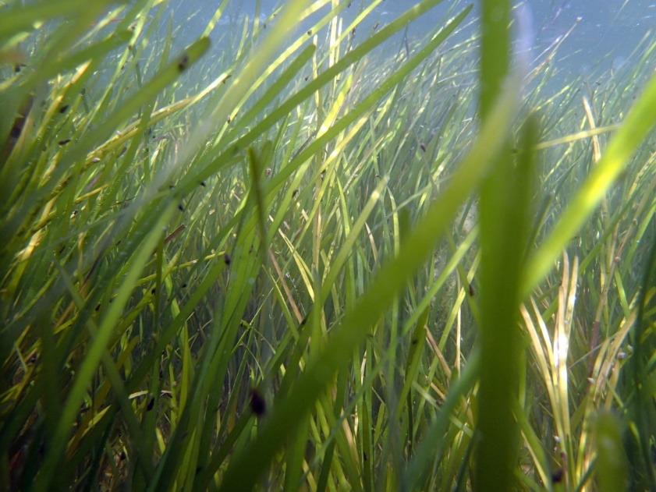

How to cite this work: Seagrass Habitat Monitoring Protocol (2021) Lefcheck, Jonathan, Tennenbaum Marine Observatories Network, MarineGEO, Smithsonian Institution. https://doi.org/10.25573/serc.14925114. [v1](https://doi.org/10.25573/serc.14925114.v1)



Introduction

In this document, we provide MarineGEO’s standard survey design for sampling seagrass habitats, including key measurements of the plants, associated fauna, and other properties of the ecosystem. Additionally, we provide define best practices for site selection, layout, and workflow.

The overall design and replication adheres as closely as possible to other seagrass monitoring programs, such as SeagrassNET and Seagrass Watch. Our goal is to provide a standardized sampling design and measurements of the key aspects of seagrass habitats that can be compared globally. We thank Fred Short and Bob Orth for thoughtful feedback on the initial draft of these protocols and Valerie Paul and Rachel Collin for leading major revisions.

This protocol provides data on above- and belowground seagrass biomass, composition, and shoot density from a standard core. Additional copies of this protocol, field datasheets, and data entry templates can be found at <https://doi.org/10.25573/serc.14925114>

Required protocols for MarineGEO partners:

• Sampling Event & Environmental Monitoring (temperature, salinity, turbidity) - https://doi.org/10.

[25573/serc.14555511](https://doi.org/10.25573/serc.14555511)

• Seagrass density (cover, composition, shoot density)

• Seagrass shoots (leaf length, width, epiphytes)

• Predation (bait loss; ‘Squidpops’) - https://doi.org/10.25573/serc.14717802

Recommended protocols:

• Beach seines ([https://doi.org/10.25573/serc.14925105),](https://doi.org/10.25573/serc.14925105) Trawl, or Visual Diver Survey (https://doi. [org/10.25573/serc.14717796)](https://doi.org/10.25573/serc.14717796) - fish and mobile invertebrate abundance, length, composition

• Sediment organic matter (bulk density, organic carbon) - https://doi.org/10.25573/serc.14925111

• Seagrass biomass (biomass, shoot density)

• Seagrass epifauna (composition, biomass)

• Seagrass macroalgae (biomass)

Requirements

Personnel: 2 people

Estimated Total Time Per Location (*n* =transects): Preparation: 1 person x 1 day

Field work: 2 people x 1-2 days per location, 2-4 days total

Sample post-processing: Variable - see individual protocols

Data processing: 1 person x 1-2 days

*Estimated times will vary by site and conditions

Materials:

* 1 50-m metric transect tape
* Hand-held GPS unit
* 2 PVC marker poles (diameter and length as needed)
* Waterproof camera

Methods

Preparation:

1. Identify the required and any recommended modules above that you wish to conduct at your site. Label 18 disposable plastic bags with the sampling location, transect, and replicate number using a permanent marker.
2. Familiarize yourself with the methods (including data preparation and submission) of each protocol. Fill a container with ice immediately before departing for the field.
3. Contact [marinegeo-protocols@si.edu to](mailto:marinegeo-protocols@si.edu) schedule a brief conference to discuss your project and address any questions before proceeding to the next steps.
4. Acquire all the necessary permits required to sample at your sites. This includes ethics approval from your Institutional Animal Care and Use Committee (IACUC), if necessary.
5. Review and follow the safety requirements from your institution. MarineGEO is not responsible for any loss or injury incurred during sampling.

Site Selection:

1. Identify three seagrass beds (locations) to sample. Beds should be:
   1. Typical of your region;
   2. Large enough to deploy three 50-m transects;
   3. Reasonably accessible;
   4. Generally persistent (so that they can be visited from year-to-year).
2. Contact [marinegeo-protocols@si.edu to](mailto:marinegeo-protocols@si.edu) verify your sites with our team and to receive permanent standard MarineGEO site codes before heading to the field.
3. Record GPS coordinates at each sampling location. Take photos of the surrounding landscape and some underwater photos of the seagrass habitat for each trip. Also record field notes on the general layout and condition of the habitat, conspicuous features or organisms, etc.
4. Lay out and mark the positions of three 50-m fixed transects with durable infrastructure so that they can be relocated in the future: these transects are intended to be permanent (i.e., sampled repeatedly). Place the transects parallel to shore and representing the shallow (inshore), middle (interior), and deep (offshore) parts of the bed (Fig. 1):
   1. If the bed is intertidal or relatively shallow, select transects that are increasingly far from shore and separated by the largest distance that is logistically feasible.
   2. If the bed extends into water too deep to work in, deploy the transects at the maximum distance from shore that is logistically feasible.
   3. Ensure that the transects are reasonably independent (separated by a minimum of 5-10 m). If it’s not possible to arrange 3 transects within the bed so that they are not overlapping or they are too close, contact [marinegeo-protocols@si.edu for](mailto:marinegeo-protocols@si.edu) further guidance.
   4. If in subsequent years the margins of the bed change such that the transects are no longer in seagrass, conduct as many of the surveys as possible at the former position, then move the transect to a new fixed position so that as much of the transect is in seagrass as possible.
5. If you intend to use continuous monitoring sondes or loggers to characterize the abiotic environment, deploy them at least 2-4 weeks in advance (at least one per site).

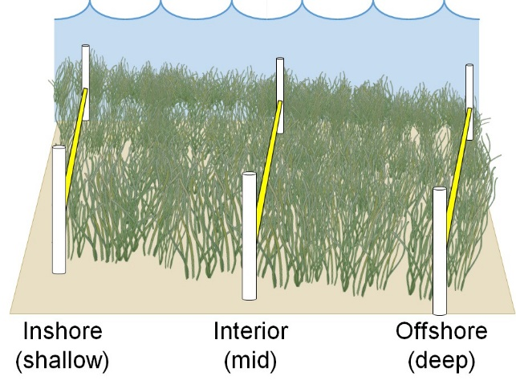Fieldwork: Day 1

1. Measure environmental conditions.
2. Deploy predation assay (n =25 ‘Squidpops’) posi-

tioned roughly every 2 m along a single transect

(Fig. 2). Choose one of the three transects that

will ensure that the baits are submerged for the en-

tire 24-hourt deployment.

1. One hour after deployment, score bait loss from the

predation assay.

1. RECOMMENDED: Before deploying predation as-

say, quantify fishes and large mobile invertebrates

by conducting either a Beach seine, Trawl, or Diver

visual census at or near the transects within or im-

Figure 1: Position of three 30-m transects within a bed.

mediately adjacent to the seagrass bed.

Fieldwork Day 2

1. Return to the site.
2. RECOMMENDED: Conduct a second replicate of Beach seine, trawl, or diver visual census.
3. Score 24h bait loss from predation assay. Retrieve stakes and any associated markers.
4. Along each transect, conduct the following (Fig. 2):
   1. Use Seagrass Density Protocol to survey percent cover, composition, and shoot density (every 4m, n = 12 per transect).
   2. RECOMMENDED: Use Seagrass Macroalgae Protocol to collect macroalgae from within the quadrats used for the Seagrass Density Protocol (every 8m, n = 6 per transect).
   3. Use Seagrass Shoots Protocol to collect shoots for later measurement of leaf characteristics, fouling load, and disease in the lab (every 8m, n = 6 per transect).
   4. RECOMMENDED: Use Sediment Organic Matter protocol to sample organic carbon in sediments for later processing in the lab (every 16m, n = 3 per transect).
   5. RECOMMENDED: Use Seagrass Biomass Protocol to sample above- and belowground biomass of seagrass and shoot density for later processing in the lab (every 16m, n = 3 per transect).
   6. RECOMMENDED: Use Seagrass Epifauna Protocol to sample epifaunal community structure for later processing in the lab (every 8m, n = 6 per transect).
5. Take destructive samples (shoot collections, epifaunal collections) at least 1m from the permanent quadrats (Fig 3).
6. Return all samples to the lab for processing.

Sample Post-Processing:

1. Activities from Day 1 require no post-processing.
2. The samples collected on Day 2 should be processed within the following time frames:
   1. RECOMMENDED: Seagrass macroalgae: within 24-48 hours
   2. Seagrass shoot collections: within 24h
   3. RECOMMENDED Sediment organic matter: within 1-3 days
   4. Seagrass biomass cores:
      1. Macrophytes: within 24h
      2. Dry mass: within 1-3 days
   5. RECOMMENDED: Seagrass epifauna:
      1. Macrophytes: within 24h
      2. Dry mass: within 1-3 days
      3. Epifauna (preserved): at leisure

Data Submission

1. Scan the completed field data sheets and save both paper and electronic versions locally. We do not require you to submit the scanned forms.
2. Enter data into the provided data entry template. Each template is an Excel spreadsheet. Please provide as much protocol and sample metadata as possible. Use the “notes” columns to provide additional information or context if a relevant column doesn’t already exist, rather than renaming or creating columns.
3. Use our online submission portal to upload the Excel Spreadsheet: <https://marinegeo.github.io/data-submission>
4. Contact us if you have any questions: [marinegeo-protocols@si.edu](mailto:marinegeo-protocols@si.edu)

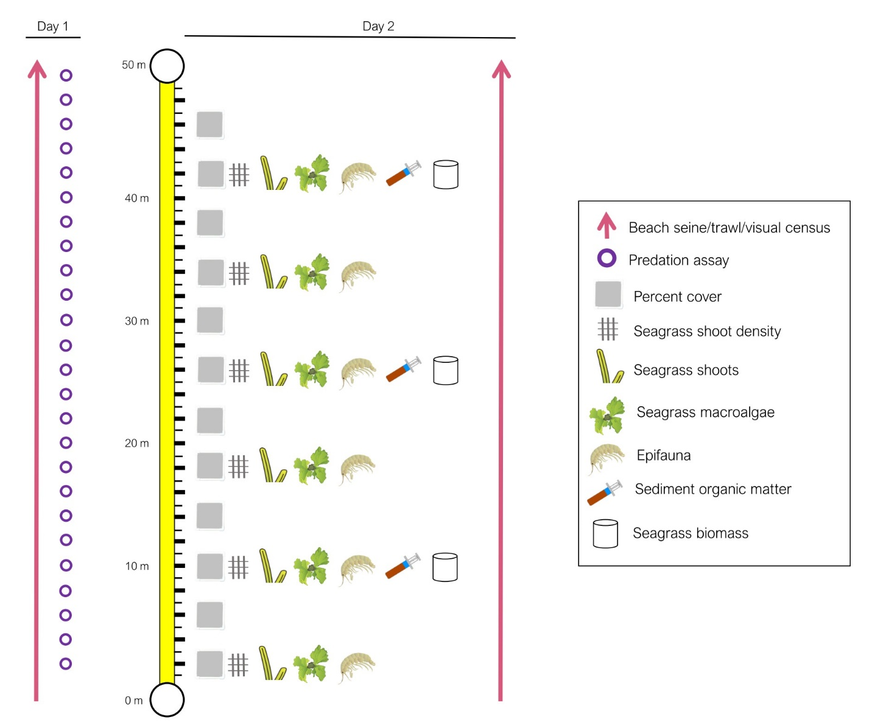

Figure 2: The placement of different replicate modules (including both core and recommended) along an example transect, and their timing of deployment.

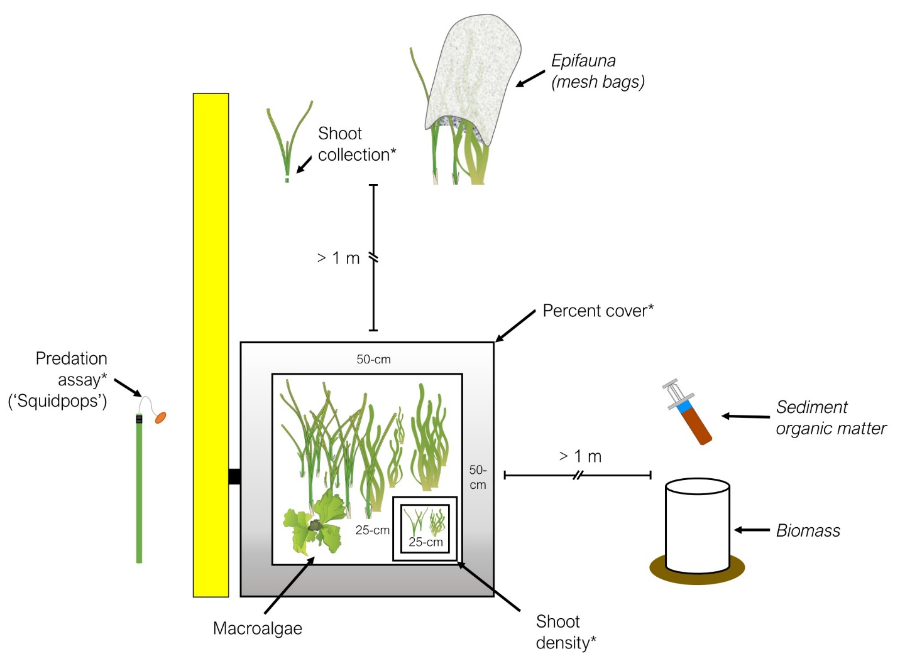

Figure 3: Example assays to be conducted along each transect (refer to Fig. 2 for more details). Required modules are indicated with an asterisk (*).

MarineGEO Seagrass Cover and Density Protocol

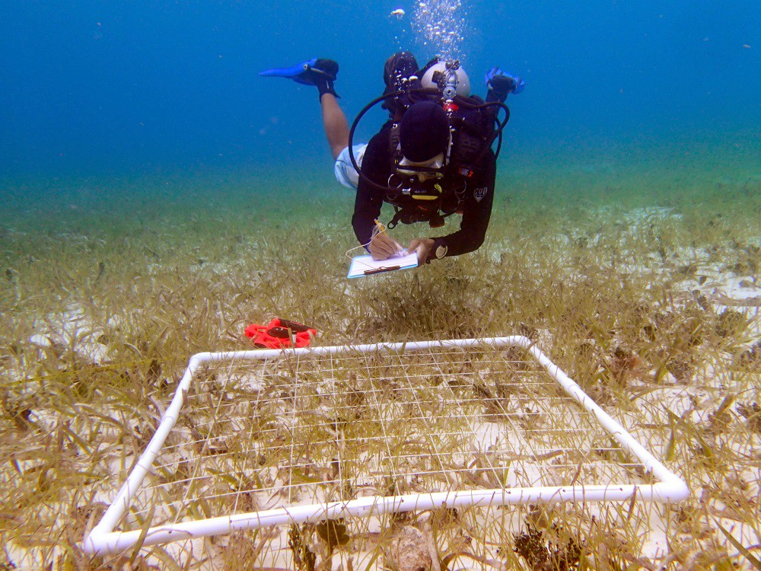

How to cite this work: Seagrass Habitat Monitoring Protocol (2021) Lefcheck, Jonathan, Tennenbaum Marine Observatories Network, MarineGEO, Smithsonian Institution. <https://doi.org/10.25573/serc.14925114.v1>



# Introduction

This protocol provides standardized data on seagrass percent cover, species composition, and shoot density using a common non-destructive method: the quadrat. Additional copies of this protocol, field datasheets, and data entry templates can be found at <https://doi.org/10.25573/serc.14925114.v1>.

# Measured Parameters

This assay quantifies seagrass community structure, measured as:

* Percent cover of each seagrass and macroalgae species (0.25 m-2)
* Macroinvertebrate abundance (number 0.25 m-2) and approximate size (cm)
* Shoot density (number 0.0625 m-2)

# Requirements

Personnel: 2 people

Estimated Total Time Per Location (*n* = 3 transects):

Preparation: 1 person x 1 day

Fieldwork: 2 people x 1 day Post processing: None

Data processing: 1 person x 1 day

*Estimated times will vary by site and conditions

Replication: Twelve (12) quadrats taken along three (3) transects (total *n* = 36 per location)

Materials:

Survey Design:

* 1 50-m metric transect tape
* Hand-held GPS unit
* 2 PVC marker poles (diameter and length as needed)

Fieldwork:

* Quadrats to measure cover and density. (Recommended: 50 x 50 cm quadrat for cover and 25 x 25 cm quadrat for density, OR any size that collects best representative samples of cover and density at your site
* Pencil
* Seagrass Cover datasheet printed on waterproof paper
* Seagrass Density datasheet printed on waterproof paper
* Clipboard
* *RECOMMENDED:* Waterproof camera

# Methods

Fully review this and any additional protocols necessary for the sampling excursion. Address any questions or concerns to [marinegeo-protocols@si.edu](mailto:marinegeo-protocols@si.edu) before beginning this protocol.

Preparation:

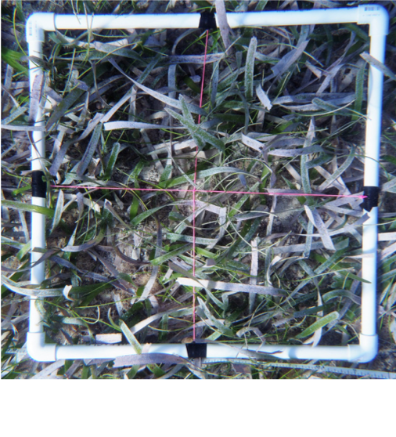

Figure 1: An example 1m x 1m PVC quadrat divided into four equal quadrats using string.

1. Review the MarineGEO Seagrass Habitats Survey Design for site selection and setup. This protocol assumes *n* = 12 quadrats for percent cover taken every 4m and *n* = 6 shoot density counts taken every 8m along a 50-m transect, replicated along 3 separate transects.
2. Print field data sheets on waterproof paper. You will need at least 3 sheets but having more available is useful, especially when >1 seagrass species is present.

Fieldwork:

1. At each predetermined point along the transect where the sample is to be collected, lay down a quadrat immediately adjacent to the transect line (either side is fine, just remain consistent). If visibil- ity is too poor to perform a visual survey of percent cover, skip to step 5.
2. Estimate and record cover of the following:
   1. Each seagrass species;
   2. Other sessile organisms (e.g., macroalgae,

sponges, etc.).

Be as specific as you can in

identifying these organisms but

do not guess if you are unsure (e.g., record ‘red sponge’ not ‘Acarnus erithacus?’);

* 1. Bare substratum. Note the type (e.g., sand, mud, mixed).

Acceptable methods for estimating cover include:

1. Assign percentage bins (represented by letters) according to the modified Braun-Blanquet method2 described in Table 1.
2. Estimate cover to the nearest 5
3. Point count: using a quadrat fitted with a grid, record cover type under each grid intersection. Record the total number of points counted on your datasheet.

Note that for methods a and b, total cover can exceed 100% if, for example, macroalgae exists on top of seagrass. Be sure to record the **dimensions of your quadrat** and the **method used** (Braun-Blanquet,

% bins, or point count) on your datasheet.

**Table 1.** Values of the modified Braun-Blanquet scale representing discrete percent cover bins. Each letter of the modified bins corresponds to a number representing a bin from the Braun-Blanquet scale. Please use letter bins in data entry spreadsheets to facilitate the MarineGEO data curation process (and not to be confused with numeric % cover).

|  |  |  |  |
| --- | --- | --- | --- |
| Modified Braun-Blanquet Bin | Braun-Blanquet Bin | Interpretation | Cover |
| A | 0 | Absent | 0% |
| B | 0.1 | A single shoot (1-2% cover) | < 5% |
| C | 0.5 | A few shoots (3-5% cover) | < 5% |
| D | 1 | Some cover | 5-25% |
| E | 2 | Moderate cover | 25-50% |
| F | 3 | Majority cover | 50-75% |
| G | 4 | Total or near total cover | 75-100% |

1. Record the presence and approximate size of any large mobile benthic macroinvertebrates (>10 cm) that fall within the quadrat and are immediately visible in the quadrat (e.g., gastropods, urchins, sea cucumbers).
2. In every *other* replicate, obtain a measurement of shoot density by counting and recording the number of seagrass shoots within a 25 x 25 cm quadrat (or other fixed area of appropriate size for your site) (**specify dimensions** on your datasheet). If visibility is poor, shoot density can be obtained by touch. Record shoot counts on the Seagrass Density datasheet.
3. If shoot densities cannot be assessed visually OR by touch, a biomass core can be used to destructively sample the bed and count shoot densities in the lab (see: Seagrass Biomass Core protocol).
4. Repeat steps 1-5 for all replicates along the first transect.
5. Repeat steps 1-6 for the remaining two transects.

2Fourqurean, J. W., Willsie, A., Rose, C. D., & Rutten, L. M. (2001). Spatial and temporal pattern in seagrass community composition and productivity in south Florida. Marine Biology, 138(2), 341-354.

# Data Submission

1. Scan the completed field data sheets and save both paper and electronic versions locally. We do not require you to submit the scanned forms.
2. Enter data into the provided data entry template. Each template is an Excel spreadsheet. Please provide as much protocol and sample metadata as possible. Use the “notes” columns to provide additional information or context if a relevant column doesn’t already exist, rather than renaming or creating columns.
3. Use our online submission portal to upload the Excel Spreadsheet: [https://marinegeo.github.io/data-](https://marinegeo.github.io/data-submission) [submission](https://marinegeo.github.io/data-submission)
4. Contact us if you have any questions: [marinegeo-protocols@si.edu](mailto:marinegeo-protocols@si.edu)

MarineGEO Seagrass Shoots Protocol

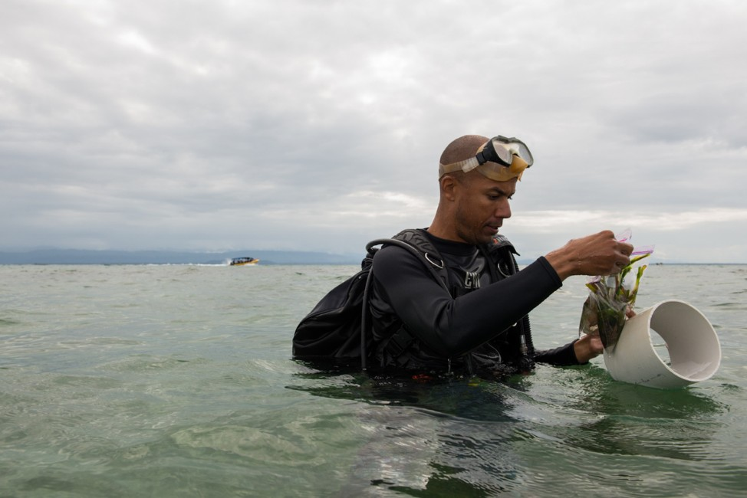

How to cite this work: Seagrass Habitat Monitoring Protocol (2021) Lefcheck, Jonathan, Tennenbaum Marine Observatories Network, MarineGEO, Smithsonian Institution. <https://doi.org/10.25573/serc.14925114.v1>



# Introduction

This protocol provides standardized data on characteristics of the seagrass canopy and fouling/sessile (attached) organisms on the seagrass blades from shoot collections. Additional copies of this protocol, field datasheets, and data entry templates can be found at <https://doi.org/10.25573/serc.14925114.v1>.

# Measured Parameters

This assay quantifies physical characteristics of seagrass blades and the associated fouling community, measured as:

* Individual blade length (mm)
* Individual blade width (mm)
* Sheath length (mm)
* Total blade mass (mg)
* Grazing scars (number)
* Total fouling biomass (mg)

# Requirements

Personnel: 2 people

Estimated Total Time Per Location (*n* = 3 transects):

Preparation: 1 person x 1 day Field work: 2 people x 1 day

Post processing: 1 person x 3-5 days Data processing: 1 person x 1 day

*Estimated times will vary by site and conditions

Replication: Six (6) shoot samples (1 shoot of each of the dominant species) taken along three (3) transects (total *n* = 18).

Materials:

Survey Design:

* 1 50-m metric transect tape
* Hand-held GPS unit
* 2 PVC marker poles (diameter and length as needed)

Fieldwork:

* 18 plastic bags with external and internal labels [(example)](https://ziploc.com/en/Products/Bags/Sandwich-and-Snack/Sandwich-Bags)
* 1 cooler with ice (optional)

Post-Processing:

* 72+ pre-weighed foil tins [(example)](https://www.thomassci.com/Laboratory-Supplies/Weighing-Dishes/_/Aluminum-Weighing-Boats?&q=Weigh%2BBoat)
* Sorting tray
* Pencil/pen
* Permanent marker
* Microscope slide or other scraping instrument
* Ruler (mm)
* Drying oven

# Methods

Fully review this and any additional protocols necessary for the sampling excursion. Address any questions or concerns to [marinegeo-protocols@si.edu](mailto:marinegeo-protocols@si.edu) before beginning this protocol.

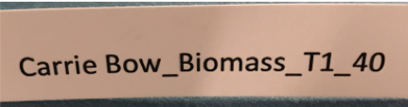Preparation:

1. Review the MarineGEO Seagrass Habitats Survey Design for site selection and setup. This protocol assumes *n* = 6 shoots taken every 8 m along a 50-m transect, replicated along 3 separate transects.
2. Label 18 disposable plastic bags with the sampling location, transect, and replicate number using a permanent marker.

Figure 1: Example label with site (Carrie Bow), method (biomass), transect (1), and replicate (40 m).

1. Place 18 internal labels with the same metadata written on waterproof paper inside the corresponding plastic bag (Fig. 1).
2. Fill a container with ice immediately before departing for the field.

Fieldwork:

1. At each predetermined point along the transect where the sample is to be collected, randomly select a patch ~1 m to any side of the transect. Be sure *NOT* to sample within the 0.5-0.5 m quadrat used for quantifying percent cover and shoot density, as this may affect cover and density surveys in subsequent years.
2. Use your fingers to gently break off a single seagrass shoot at the base of the shoot at the rhizome (Fig. 2), being careful not to disturb any material on the shoot. For some species this may require digging into the sediment to acquire the entire sheath. Place the shoot and any attached material into the corresponding labeled plastic bag.
3. If a quadrat contains more than 1 seagrass species, repeat this procedure for each seagrass species and store in the same labeled plastic bag.
4. Place the bag and contents on ice in the container.
5. Repeat steps 1-4 at the at the remaining 5 sampling locations along the transect.
6. Repeat steps 1-5 for the remaining two transects.
7. Transport container with samples back to the lab for immediate processing.

Post-Processing: Samples are best processed immediately (within 24 hours) upon returning from the field. Samples can be stored for longer in the freezer but risks decay.

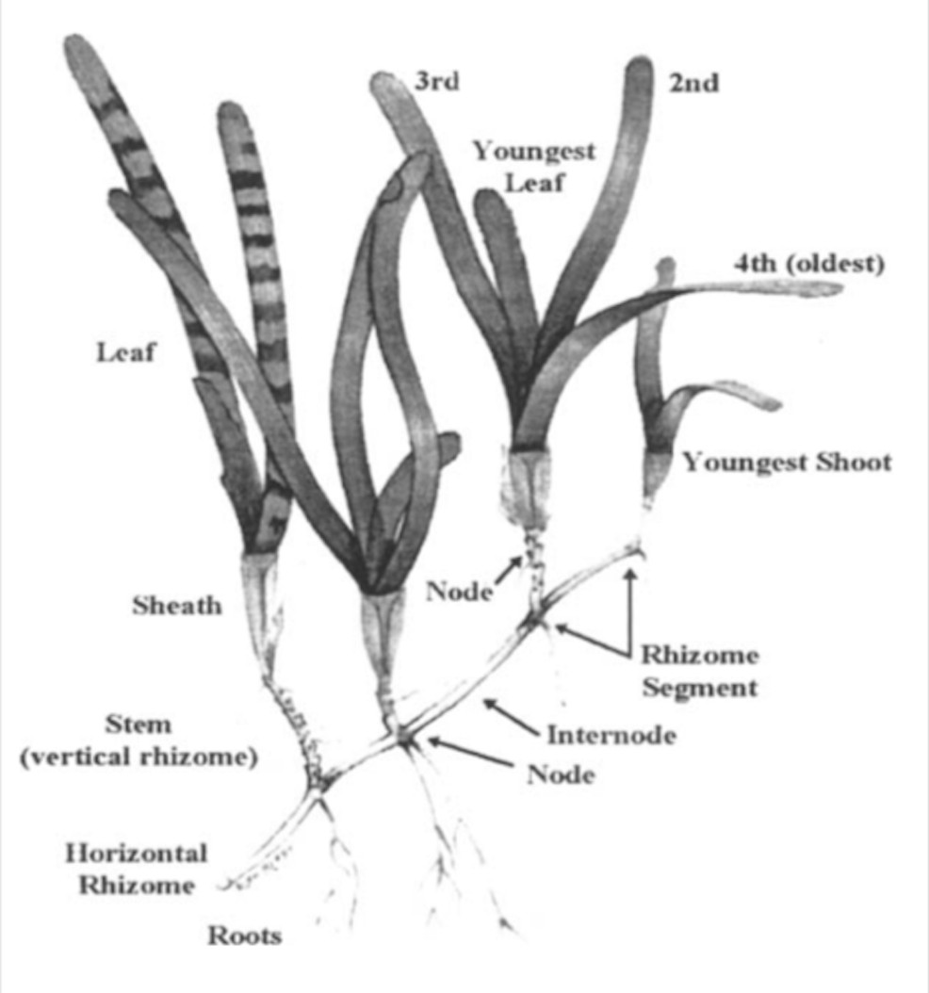

Figure 2: Morphology of seagrasses (*Cymodocea serulata* pictured). From: Short, F. T., & Coles, R. G. (Eds.). (2001). Global seagrass research methods (Vol. 33). Elsevier.

* 1. Print lab data sheets.
  2. Weigh foil tins and record the weight of the tin directly on the foil using a pen. Tins can be either pre-made, or constructed by folding an aluminum foil square over on itself and sealing the sides.
  3. Select a labeled bag and record the metadata on the lab data sheet.
  4. Gently transfer the shoot from the bag into a shallow sorting tray without any water.
  5. Separate seagrasses by species (if more than one). If any belowground material was accidentally sampled, separate by gently pinching at the meristem (the intersection of the shoots and rhizomes) and discard it.
  6. For each seagrass species, select a pre-weighed tin and label with the sample metadata (replicate number, date, location) and species name (to lowest taxonomic group), and contents (fouling material).
  7. Lightly scrape the fouling material, including epiphytic algae and sessile invertebrates, from the surface of the blades into one of the pre-weighed tins. *Be careful that no mobile (non-sessile) animals are transferred with the scraped material. This may require picking animals one-by-one out of more complex samples.* For sites with highly abundant epifaunal communities, you can gently submerge the shoot in freshwater for 30-60 seconds to remove any mobile animals (being careful not to dislodge the attached material).
  8. Next, for each shoot of each species, measure and record:
     1. The sheath length of the entire shoot: from the top of the sheath surrounding the leaf bundle to the meristem (the visible constriction at the shoot base) (Fig. 2); and
     2. The length, width, and rank of each leaf (youngest to oldest, Fig. 2).
  9. Examine each blade for any evidence of grazing scars and record the presence/absence on the lab sheet.
  10. Transfer the scraped blades into a pre-weighed tin labeled with the sample metadata (replicate number, date, location) and species name (to lowest taxonomic group), and contents (blades). If the sample contains more than one species of seagrass, weigh each species in a separate tin.
  11. Place all the tins (fouling material and blades) in a drying oven at 60°C. Dry samples until they register a constant weight (usually 1-3 days, depending on the volume of material).
  12. Remove tins from the oven and weigh each to the nearest mg. Record this dry mass (including foil) on the lab data sheet. Note: you will have *at least* two weights per sample: fouling dry-mass, and blade dry-mass of 1 or more seagrass species.

# Data Submission

1. Scan the completed field data sheets and save both paper and electronic versions locally. We do not require you to submit the scanned forms.
2. Enter data into the provided data entry template. Each template is an Excel spreadsheet. Please provide as much protocol and sample metadata as possible. Use the “notes” columns to provide additional information or context if a relevant column doesn’t already exist, rather than renaming or creating columns.
3. Use our online submission portal to upload the Excel Spreadsheet: [https://marinegeo.github.io/data-](https://marinegeo.github.io/data-submission) [submission](https://marinegeo.github.io/data-submission)
4. Contact us if you have any questions: [marinegeo-protocols@si.edu](mailto:marinegeo-protocols@si.edu)

MarineGEO Seagrass Core Biomass Protocol

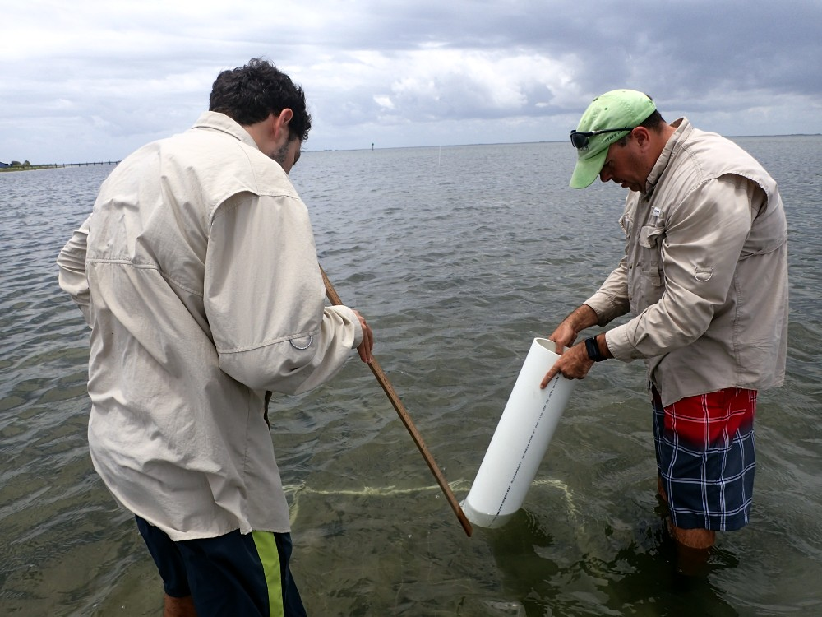

How to cite this work: Seagrass Habitat Monitoring Protocol (2021) Lefcheck, Jonathan, Tennenbaum Marine Observatories Network, MarineGEO, Smithsonian Institution. <https://doi.org/10.25573/serc.14925114.v1>



# Introduction

This protocol provides data on above- and belowground seagrass biomass, composition, and shoot density from a standard core. Additional copies of this protocol, field datasheets, and data entry templates can be found at <https://doi.org/10.25573/serc.14925114.v1>.

# Measured Parameters

This assay quantifies seagrass biomass, measured as:

* Aboveground macrophyte biomass (mg)
* Belowground macrophyte biomass (mg)
* Shoot density (number of shoots)

# Requirements

Personnel: 2 people

Estimated Total Time Per Location (*n* = 3 transects):

Preparation: 1 person x day   
Field work: 2 people x 1 day  
Post processing: 1 person x 3-5 days   
Data processing: 1 person x 1 day

*Estimated times will vary by site and conditions

Replication: Three (3) core samples taken along three (3) transects (total *n* = 9 per location)

Materials:

Survey Design:

* 1 50-m metric transect tape
* Hand-held GPS unit
* 2 PVC marker poles (diameter and length as needed)

Fieldwork:

* 9 draw-string mesh bags (roughly 1 mm mesh size, approximately 25cm x 35cm or sized as needed) [(example)](https://www.aliexpress.com/item/32625056457.html)
* 9 plastic bags (large enough to hold mesh bags) [(example)](https://ziploc.com/en/Products/Bags/Storage/Storage-Bags-Gallon-Large)
* Sediment corer (round; 15cm diameter-by-20cm length)
* Large (2-lb) hammer or mallet (optional, recommended if diving)
* 1 cooler with ice (optional)

Post-Processing:

* 20+ pre-weighed foil tins [(example)](https://www.thomassci.com/Laboratory-Supplies/Weighing-Dishes/_/Aluminum-Weighing-Boats?&q=Weigh%2BBoat)
* Sorting tray
* Pen/pencil
* Permanent marker
* Ruler (mm)
* Drying oven

# Methods

Fully review this and any additional protocols necessary for the sampling excursion. Address any questions or concerns to [maringeo-protocols@si.edu](mailto:maringeo-protocols@si.edu) before beginning this protocol.

Preparation:

1. Review the MarineGEO Seagrass Habitats Survey Design for site selection and setup. This protocol assumes *n* = 3 cores taken every 12m along a 50-m transect, replicated along 3 separate transects per location.
2. Place an internal label written on waterproof paper with the site, method, transect, and replicate number inside each of 9 plastic bags (Fig. 1).
3. Label the outside of the bags with the same information using a permanent marker.
4. Fill a cooler with ice immediately before departing for the field.

Fieldwork:

Figure 1: Example label with site (Carrie Bow), method (biomass), transect (1), and replicate (40 m).

1. At each point along the transect where the sample is to be collected, haphazardly toss the PVC core tube ~1 m to any side of the transect to obtain a random representative patch of bottom. Be sure NOT to sample within the quadrat used for quantifying percent cover, as this may affect surveys in subsequent years.
2. Place the sediment corer over the bottom. Guide the seagrass through the corer opening to ensure that no seagrass blades are severed in step 3.
3. Push or hammer the corer into the sediment to ~10-15 cm depth.
4. Gently pry the corer up and away from the benthos. To prevent the sediment from falling out of the core, work your hand under the corer and use it to support the sediment within the corer as you lift up.
5. Alternatively, if the seagrass will not fit in the core tube or if the core would obtain fewer than three(3) shoots, select a single shoot and remove it from the sediment so that the leaves, sheath/stem, and ~7-cm of horizontal rhizome with roots are taken intact.
6. Deposit the seagrass sample into the mesh bag. Close the opening, and gently agitate the sample in the water to remove loose sediment.
7. Place the mesh bag with the seagrass in the corresponding labeled plastic bag, and store in a cool, wet environment for transport to lab.
8. Repeat steps 1-7 at the at the remaining 2 sampling locations along the transect.
9. Repeat steps 1-8 for the remaining two transects.
10. Transport samples back to the lab for processing.

Post-Processing:

Samples are best processed immediately (within 24 hours) upon returning from the field. Samples can be stored for longer if frozen, but this risks damaging the organisms and making them difficult to identify, and so is discouraged.

Figure 2: Morphology of seagrasses (*Cymodocea serulata* pictured). From: Short, F. T., & Coles, R. G. (Eds.). (2001). Global seagrass research methods (Vol. 33). Elsevier.

1. Print lab data sheets.
2. Weigh foil tins and record the mass of the tin directly on the foil using a pen. Tins can be either pre-made, or constructed by folding an aluminum foil square over on itself and sealing the sides.
3. Open a plastic bag and record the metadata from the internal label on the lab data sheet.
4. Gently transfer the contents of the mesh bag within the plastic bag into a shallow sorting tray with water.
5. Sort all seagrasses and macroalgae by species.
6. Separate seagrasses into above- and belowground components by gently pinching at the meristem (the intersection of the shoots and rhizomes) until they separate (Fig. 2).
7. For each seagrass species, select a pre-weighed tin and label with the label information (replicate number, date, location), species name (to lowest taxonomic group), and contents (above- or belowground material). Place the macrophytes into the corresponding tins. For each non-seagrass macrophyte species (e.g., unrooted macroalga), place entire individuals into labeled tins. Be careful that no animals are transferred with the macrophytes. This may require picking animals one-by-one out of more complex substrates.
8. If shoot density could not be obtained in the field (see: Seagrass Density protocol) additionally count the total number of shoots of each species in each sample.
9. For each taxon sorted above: record the sample data, species name, the empty tin weight, and the number of shoots on the lab data sheet.
10. Repeat steps 3-9 for all samples.
11. Place tins containing macrophytes into a drying oven. Dry at 60°C to constant weight (usually 1-3 days, depending on the volume of material).
12. Once dried, remove all tins from the oven and weigh to nearest mg. Record this weight (including tin weight) on the lab data sheet.

# Data Submission

1. Scan the completed field data sheets and save both paper and electronic versions locally. We do not require you to submit the scanned forms.
2. Enter data into the provided data entry template. Each template is an Excel spreadsheet. Please provide as much protocol and sample metadata as possible. Use the “notes” columns to provide additional information or context if a relevant column doesn’t already exist, rather than renaming or creating columns.
3. Use our online submission portal to upload the Excel Spreadsheet: [https://marinegeo.github.io/data-](https://marinegeo.github.io/data-submission) [submission](https://marinegeo.github.io/data-submission)
4. Contact us if you have any questions: [marinegeo-protocols@si.edu](mailto:marinegeo-protocols@si.edu)

MarineGEO Seagrass Epifauna Protocol

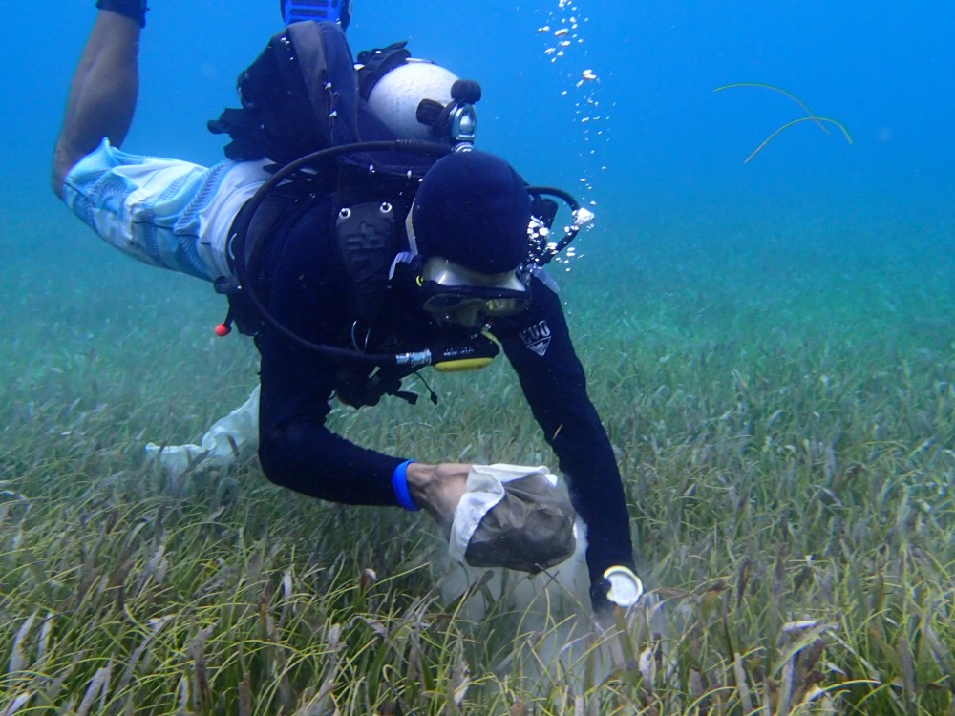

How to cite this work: Seagrass Habitat Monitoring Protocol (2021) Lefcheck, Jonathan, Tennenbaum Marine Observatories Network, MarineGEO, Smithsonian Institution. <https://doi.org/10.25573/serc.14925114.v1>



# Introduction

This protocol provides standardized data on seagrass mobile-epifauna including taxonomic composition, diver- sity, abundance/biomass, and/or secondary production. Additional copies of this protocol, field datasheets, and data entry templates can be found at <https://doi.org/10.25573/serc.14925114.v1>.

Samples collected in this protocol are post-processed to quantify aboveground seagrass biomass and estimate the biomass/secondary production of mobile epifauna. For post-processing, we recommend using a series of stacked sieves of sequentially smaller mesh sizes to sort animals into size classes (Fig. 2) as in Edgar, G.J. (1990) *Journal of Experimental Marine Biology and Ecology* 137:195-214. The abundance of each species in the size class can be combined with [empirical equations](https://gist.github.com/jslefche/c480eeb2ad67ca7c9a46) relating abundance to biomass and production of different taxonomic groups, providing non-destructive estimates of epifaunal biomass and production.

# Measured Parameters

This assay quantifies characteristics of seagrass mobile epifaunal communities, measured as:

* Epifaunal abundance and taxonomic composition (individuals)
* Epifaunal biomass (mg dry or estimated ash-free dry mass)
* Associated macrophyte biomass (mg)

# Requirements

Personnel: 2 people

Estimated Total Time Per Location (*n* = 3 transects):

Preparation: 1 person x 1 day Field work: 2 people x 1 day

Post processing: 1 person x 1 month Data processing: 1 person x 1 day

*Estimated times will vary by site and conditions

Replication: Six (6) epifaunal samples taken using mesh bags along three (3) transects (total *n* = 18 per location).

Materials:

Survey Design:

* 1 50-m metric transect tape
* Hand-held GPS unit
* 2 PVC marker poles (diameter and length as needed)

Fieldwork:

* 18 draw-string mesh bags (300-500 micron mesh size, approximate dimensions: 75x20 cm (32x7”), with 20 cm opening) [(example)](https://www.thecarycompany.com/pemu-mesh-liquid-filter-bags)
* Waterproof paper for internal labels
* 1 cooler with ice (optional)

Post-Processing:

* 20+ pre-weighted foil tins [(example)](https://www.thomassci.com/Laboratory-Supplies/Weighing-Dishes/_/501837F4-C637-4C72-80A1-2675943DCB0B?q=Weigh%20Boat)
* Sorting tray
* 20+ scintillation vials (20-mL) with lids

□ 70

* Petri dishes
* Forceps (fine-tip)
* Pen/pencil
* Drying oven

□ Nested sieve set with the following sizes: 8.0, 5.6, 4.0, 2.8, 2.0, 1.4, 1.0, 0.71 and 0.5 mm (5/16-in, #3.5, #5, #7, #10, #14, #18, #25, #35 mesh sizes respectively) [(example)](https://www.thomassci.com/Laboratory-Supplies/Sieves/_/3-Diameter-ASTM-Brass-Stainless-Round-Test-Sieves?q=Sieves)

# Methods

Fully review this and any additional protocols necessary for the sampling excursion. Address any questions or concerns to [marinegeo-protocols@si.edu](mailto:marinegeo-protocols@si.edu) before beginning this protocol.

Preparation:

1. Review the MarineGEO Seagrass Habitats Survey Design for site selection and setup. This protocol assumes 1 bag sample taken every 8 m along a 50-m transect (*n* = 6 per transect), replicated along 3 separate transects for a total *n* = 18.

Figure 1: Example label with site (Carrie Bow), method (biomass), transect (1), and replicate (40 m).

1. Write 18 internal labels on waterproof paper with the sampling location, transect, and replicate number (Fig. 1), and place inside 18 mesh bags (300-500 um mesh size).
2. Fill a container with ice immediately before departing for the field.

Fieldwork:

1. At each point along the transect where the sample is to be collected, randomly select a patch ~1 m to any side of the transect. Be sure NOT to sample within the quadrat used for quantifying percent cover, as this may affect surveys in subsequent years.
2. Position the mesh bag over the canopy and gently lower it over the seagrass, being careful to avoid disturbing or dislodging any organisms or macroalgae. It may be necessary to move the bag from side-to-side and gently guide the seagrass blades through the opening. For intertidal sites, blades can be gently lifted and inserted into the bag opening.
3. Once the opening of the bag is just above the surface of the sediment, close the bag by pulling the drawstring and cut the exposed shoots at the sediment surface to release them into the bag. Avoid bagging sediment along with the sample, which could result in accidental collection of sediment-associated organisms.
4. Invert the closed bag and bring it up to the surface, flushing the contents fully into the bottom of the bag. For intertidal sites, invert the bag and shake to move the contents fully into the bag. Then close the drawstring and tie a knot at the top of the bag to prevent the bag from accidentally opening.
5. Place the bag with contents on ice in container.
6. Repeat steps 1-5 at the next location along the first transect until all 6 replicates are taken.
7. Repeat steps 1-6 for the remaining two transects for a total of 18 samples.
8. Transport container with samples back to the lab for processing.

Post-Processing:

## Step 1: Macrophyte dry mass

* 1. Print lab data sheets.
  2. Weigh foil tins and record the weight of the tin directly on the foil using a pen. Tins can be either pre-made, or constructed by folding an aluminum foil square over on itself and sealing the sides.
  3. Open a mesh bag and record the metadata from the internal label on the lab data sheet.
  4. Gently rinse the contents of the bag into a shallow sorting tray with water. Be sure to check the seams and folds of the bag for organisms clinging to the mesh.
  5. Sort all seagrasses and macroalgae by species.
  6. For each seagrass and macroalgal species, select a pre-weighed tin and label with the sample metadata (replicate number, date, location) and species name (to lowest taxonomic group). For each seagrass, gently scrape epibiota (periphyton, sessile organisms) into a separate tin, and then place the seagrass blades into another tin. For each non-seagrass macrophyte species (e.g., unrooted macroalga), place entire individuals into labeled tins. *Be careful that no animals are transferred with the macrophytes.* This may require picking animals one-by-one out of more complex substrates. Gently shaking the blades in in the shallow tray may also help.
  7. For each taxon sorted above: record the sample data, species name, and the empty tin weight on the lab data sheet.
  8. Once no plant or algal material remains in the sorting tray, pass the contents through a 500-um or smaller mesh sieve. Gently rinse any loose material through the sieve, and then transfer the remaining contents to an internally and externally labeled 20-mL vial filled with 70% ethanol. Multiple vials may be required for larger samples or organisms. Set the vial aside for epifaunal processing at a later date.
  9. Repeat steps 3-8 for each sample.
  10. Place all tins containing macrophytes into a drying oven. Dry at 60°C to constant weight (usually 1-3 days, depending on the volume of material).
  11. Once dried, remove all tins from the oven and weigh to nearest mg. Record this weight (including tin weight) on lab data sheet.

## Step 2: Sieve Processing

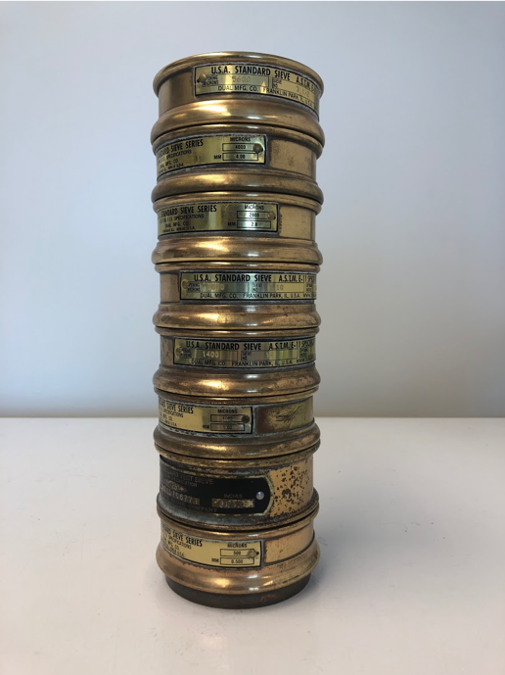This step can be done at your leisure as organisms are now preserved in 70% ethanol.

* 1. Print lab data sheets.
  2. Stack the sieves from the smallest mesh size on the bottom to the largest mesh on top (Fig. 2).
  3. Select a 20-mL vial with epifauna, open the top, and gently invert it over the top sieve, allowing the contents to pass onto the sieve tower.
  4. Use a tube or squirt bottle filled with tap or distilled water to gently rinse the contents of the vial into the sieve tower until the vial is empty.
  5. Gently rinse the animals through the sieve tower. Take care not to use too much pressure to avoid damage fragile specimens. The goal is for animals to pass through larger sieves until they reach and are retained by the sieve mesh appropriate to their body size. This may be aided by removing the top sieve, rinsing, and repeating until the

Figure 2: Example of sieve tower used to obtain size-fractionated epifaunal abundances.

last sieve.

* 1. Transfer the contents of each sieve into a separate labeled into a 10-cm Petri dish or similar for sorting.
  2. Identify each taxon in each sieve size class in each sample to species and record the species name on the lab datasheet. If you cannot reliably identify a taxon to species, identify it to the lowest taxonomic group that you feel confident. Then, give it a provisional name (e.g., Nereid polychaete A). Photograph unidentified species and label image file names with the sample information and the provisional species name you assigned on the data sheet. These images can be used to later clarify the species’ identity. *Be sure to maintain the naming scheme for all future samples* (especially if samples are processed by different people).
     1. Only count metazoans: exclude protozoans (e.g. foraminera)
     2. Only count mobile macrofauna: exclude sessile animals (e.g. bryozoans, sponges, hydroids) and meiofauana (e.g. copepods, ostracods, and larvae).
     3. Only count animals that were alive at the time of collection: discard empty shells and exoskeletons.
     4. Only count heads: this prevents counting the same individual twice. Discard disembodied limbs, posterior ends of polychaetes, crustacean bodies with missing heads, etc. If a species is not identifiable by its head parts, only count bodies instead.
  3. Count and record the number of individuals for each species on the provided lab sheet.
  4. Return all specimens to the labeled 20-mL vial, fill with 70% ethanol, and seal for long-term storage.

# Data Submission

1. Scan the completed field data sheets and save both paper and electronic versions locally. We do not require you to submit the scanned forms.
2. Enter data into the provided data entry template. Each template is an Excel spreadsheet. Please provide as much protocol and sample metadata as possible. Use the “notes” columns to provide additional information or context if a relevant column doesn’t already exist, rather than renaming or creating columns.
3. Use our online submission portal to upload the Excel Spreadsheet: [https://marinegeo.github.io/data-](https://marinegeo.github.io/data-submission) [submission](https://marinegeo.github.io/data-submission)
4. Contact us if you have any questions: [marinegeo-protocols@si.edu](mailto:marinegeo-protocols@si.edu)

MarineGEO Seagrass Macroalgae Protocol

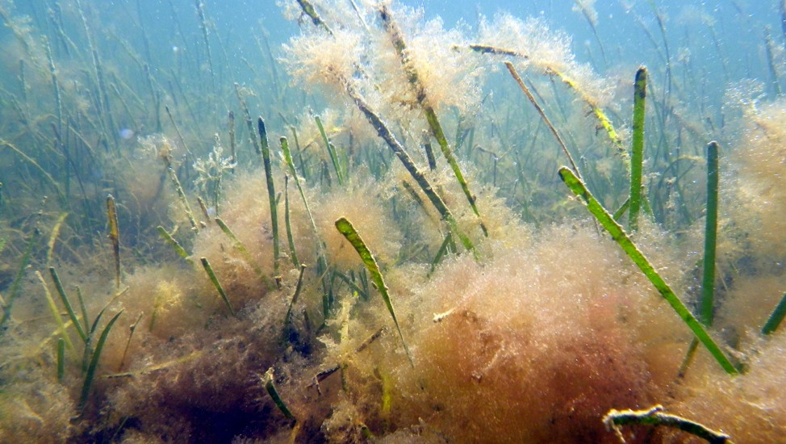

How to cite this work: Seagrass Habitat Monitoring Protocol (2021) Lefcheck, Jonathan, Tennenbaum Marine Observatories Network, MarineGEO, Smithsonian Institution. <https://doi.org/10.25573/serc.14925114.v1>



# Introduction

This protocol provides estimates of macroalgal biomass per unit area. Additional copies of this protocol, field datasheets, and data entry templates can be found at <https://doi.org/10.25573/serc.14925114.v1>.

# Measured Parameters

This assay quantifies the biomass of macroalgae, measured as:

* Macroalgal wet weight (mg)
* Macroalgal dry weight (mg)

# Requirements

Personnel: 2 people

Estimated Total Time Per Location (*n* = 3 transects):

Preparation: 1 person x 1 day Field work: 2 people x 1 day

Post processing: 1 person x 3-5 days Data processing: 1 person x 1 day

*Estimated times will vary by site and conditions

Replication: Six (6) macroalgae samples taken along three (3) transects (total *n* = 18).

Materials:

Survey Design:

* 1 50-m metric transect tape
* Hand-held GPS unit
* 2 PVC marker poles (diameter and length as needed)

□ 0.5m x 0.5m (0.25m2) quadrat

Fieldwork:

* 18 draw-string mesh bags ( 1 mm mesh size, approximately 25x35 cm or sized as needed) [(example)](https://www.aliexpress.com/item/32625056457.html)
* 1 cooler with ice (optional)

Post-Processing:

* 20+ pre-weighed foil tins [(example)](https://www.thomassci.com/Laboratory-Supplies/Weighing-Dishes/_/Aluminum-Weighing-Boats?&q=Weigh%2BBoat)
* Sorting tray
* Pencil/pen
* Permanent marker
* Ruler (mm)
* Drying oven

# Methods

Fully review this and any additional protocols necessary for the sampling excursion. Address any questions or concerns to [marinegeo-protocols@si.edu](mailto:marinegeo-protocols@si.edu) before beginning this protocol.

Preparation:

1. Review the MarineGEO Seagrass Habitats Survey Design for site selection and setup. Samples are collected concurrently with the MarineGEO [Seagrass Density](https://marinegeo.github.io/modules/seagrass-density) protocol. This protocol assumes *n* = 6 macroalgae samples taken every 8 m along a 50-m transect, replicated along 3 separate transects.
2. Label 18 disposable plastic bags with the sampling location, transect, and replicate number using a permanent marker.
3. Place 18 internal labels with the same metadata written on waterproof paper inside the corresponding plastic bag.
4. Fill a container with ice immediately before departing for the field.

Fieldwork:

1. Set up the 50-m transects and position the first quadrat. Refer to the MarineGEO Seagrass Density protocol for further instructions.
2. With the 0.5x0.5 m quadrat in place, hand collect all macroalgae within the quadrat and place in the corresponding labeled mesh bag. Limit collections to large intact macroalgae that can be picked from the bottom by hand (filamentous attached/epiphytic algae are evaluated in a separate protocol). Macroalgae with holdfasts can be broken from the substrate at the sediment surface.
3. If the macroalgal unit overlaps the bounds of the quadrat, trim using scissors at the quadrat edge.
4. Place the mesh bag and contents on ice in the container.
5. Repeat steps 1-4 at the at the remaining 5 sampling locations along the transect.
6. Repeat steps 1-5 for the remaining two transects.
7. Transport cooler with samples back to the lab for immediate processing.

Post-Processing: Samples are best processed immediately (within 24 hours) upon returning from the field. Samples can be stored for longer frozen but risk decay.

1. Print lab data sheets.
2. Weigh foil tins and record the weight of the tin directly on the foil using a pen. Tins can be either pre-made, or constructed by folding an aluminum foil square over on itself and sealing the sides.
3. Select a labeled bag and record the metadata on the lab data sheet.
4. Transfer the macroalgae from the bag into a sorting tray or bowl and rinse with freshwater. Add enough freshwater to cover the macroalgae.
5. Allow algae to soak in freshwater for approximately one minute to release any epifauna that may be clinging to it. Remove algae from the freshwater soak and check fronds for any remaining animals. Remove animals if present and discard.
6. Identify algae to species or, if taxonomy is poorly resolved, the broad functional group (e.g., red, brown, etc.). Select a pre-weighed tin and label with the sample metadata (replicate number, date, location) and contents (macroalgal species or functional group). Record tin weight (mg) on lab data sheet.
7. Place macroalga in tin.
8. Repeat steps 3-7 for each remaining macroalgal species or functional group in the sample.
9. Repeat steps 3-8 for each remaining replicate.
10. Place all the tins in a drying oven at 60°C. Dry samples until they register a constant weight (usually 1-3 days, depending on the volume of material).
11. Remove tins from the oven and weigh each to the nearest mg. Record this dry mass (including foil) on the lab data sheet.

# Data Submission

1. Scan the completed field data sheets and save both paper and electronic versions locally. We do not require you to submit the scanned forms.
2. Enter data into the provided data entry template. Each template is an Excel spreadsheet. Please provide as much protocol and sample metadata as possible. Use the “notes” columns to provide additional information or context if a relevant column doesn’t already exist, rather than renaming or creating columns.
3. Use our online submission portal to upload the Excel Spreadsheet: [https://marinegeo.github.io/data-](https://marinegeo.github.io/data-submission) [submission](https://marinegeo.github.io/data-submission)
4. Contact us if you have any questions: [marinegeo-protocols@si.edu](mailto:marinegeo-protocols@si.edu)